
Royal Weave Report

Team Member’s Name | Team Member’s ID | Team Member’s Signature
Abdulmohsen Khalid Almansour | 2230003420 | 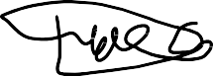
Ziyad Abdullah Alshami | 2230007306
Turki Hamad Al-Abdulgader | 2220007289 | 
Tamim Alsuhibani | 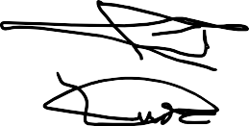  2230005888
Mohammed Hussain ALjubran | 2230002940

Major: CS Class: 8MS3 | Group: 7
Date of Submission: 13th April 2026

Contents
- Introduction 3
- Overview 3
- Database 3
  - Database design overview 3
  - Tables Structure 3
  - Entity-Relationship Design 4
- User Features 6
  - Product Listing 6
  - Product Details Page 6
  - Cart and Checkout 7
  - Navigation Flow 7
  - Contact Us Page 8
- Admin Features 8
  - Product Management 9
  - Search Functionality 9
  - Admin Navigation Flow 9
  - Admin Logout 10
- Teamwork and Contribution 10
- Conclusion 10

Introduction
This report presents the development and implementation of Royal Weave, a shopping web
prototype built using both HTML and CSS for the prototype phase. It simulates an e-commerce platform that includes varies functionalities for shopping needs

Overview
Royal Weave provides a simple and intuitive front-end to browse products, view their details and proceed to check out. Also, it includes an admin control panel that allows full product
management

Database

Database design overview
The database is designed using a relational model to ensure data consistency and integrity. It supports all core functionalities of a database system. Managing users, admins, products and orders. Design follows a normalized principle reducing redundancy and aims to reach an
efficient relationship.

Tables Structure
Databases consist of interconnected tables with each serving a role. In royal weave we designed the table structure to separate responsibilities across user, product and order management.
    - Admin and Customer tables: These tables store account information for both admins and users. Crucial for separating system control.
    - Category and Product tables: These tables organize product data and classify them into categories.
    - Product Variant Table: This table stores variant details such as price, stock quantity, size, color and image.
    - Orders and Order items tables: These tables store the checkout process by storing cart information, completed orders, quantities and prices.

    - User session and Activity Log tables: These tables record and store login sessions and activities. Such as viewing products, adding items to carts and placing orders. Tracking user behavior ensuring better experience.
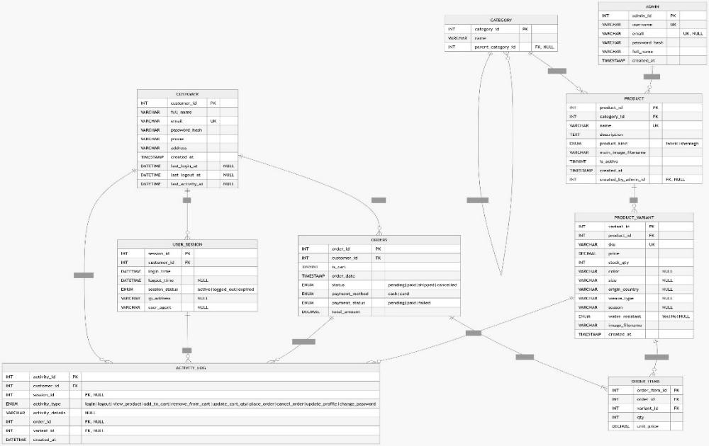

Entity-Relationship Design
The Entity-Relationship design explains how tables interconnect, using primary and foreign keys. Relationships are Crucial to ensure that the database runs as one mind.
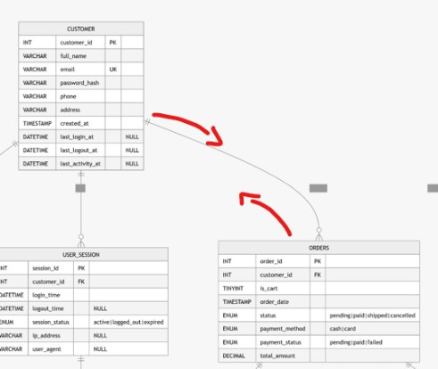
    - Customer to Orders relationship: One customer can create multiple orders.
    - Orders to Order items relationship: One order can contain many items.
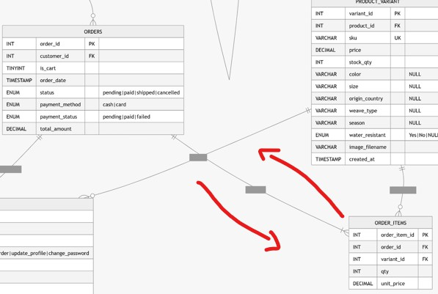

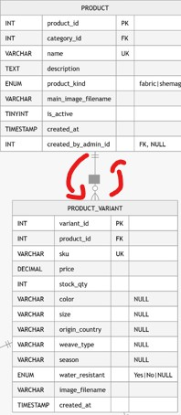
    - Product to Product Variant relationship: One product can have multiple variants.
    - Category to Product relationship: Each product belongs to a category.
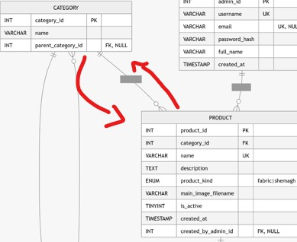
    - Customer to Session and Activity Log relationships: A customer can have multiple sessions and activity records.
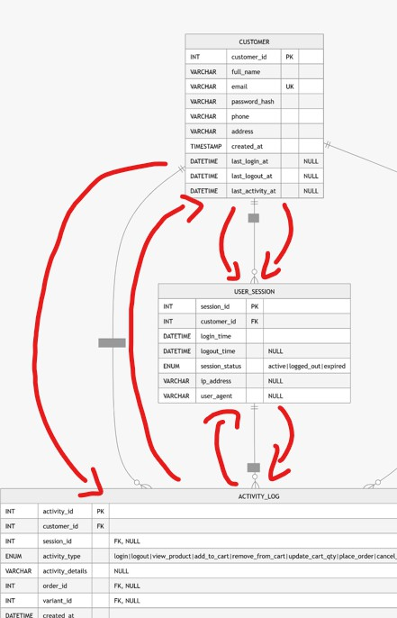
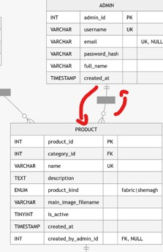
    - Admin to product relationship: An Admin can create or manage products.

User Features

Product Listing
User has a display of varieties of available products in an organized fashion, where each product includes an image and basic information. A cart icon is also displayed allowing fast access to
check out. Ensuring ease and fast browsing.
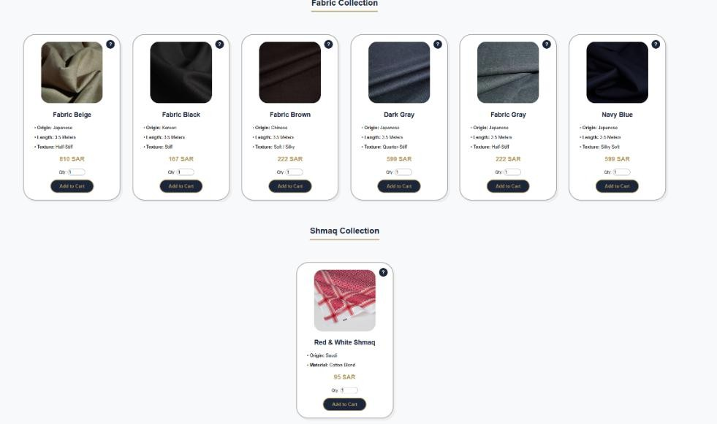

Product Details Page
When the user clicks on a product, they are directed to a detailed view of the selected product providing comprehensive information. Includes price, availability, and help.
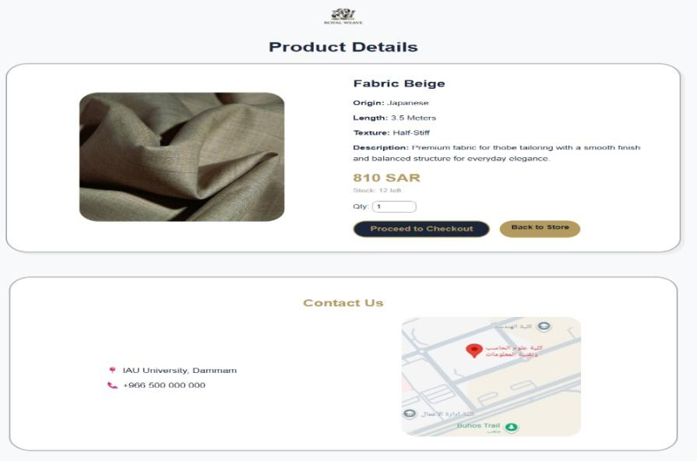

Cart and Checkout
Cart And checkout allow a user to manage their selected items in a singular page efficiently. Users can modify, delete, remove or proceed with selected items.

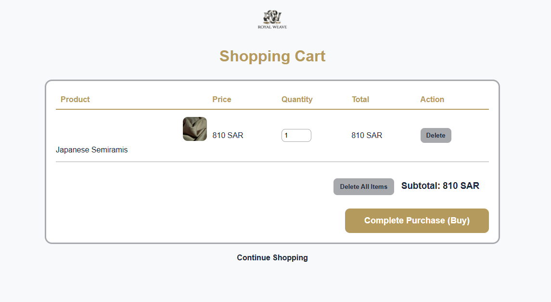

Navigation Flow
The navigation flow is designed to be as straightforward as possible. Ensuring a user-friendly environment. Clicking on a product directs the user to a details page, from which they can
proceed to check out. Also, users can access the checkout page and add the selected product to
the cart by simply clicking on the cart icon. Additionally, a Contact Us page is accessible through the menu.
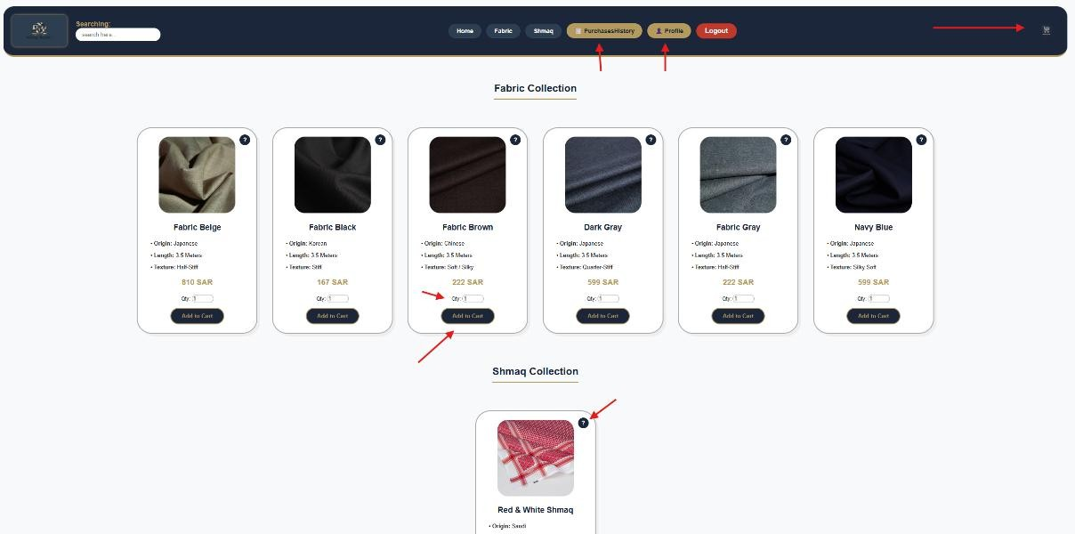

Contact Us Page
Contact Us page gives the user information regarding the location and a map for better visualization. Enhancing credibility.
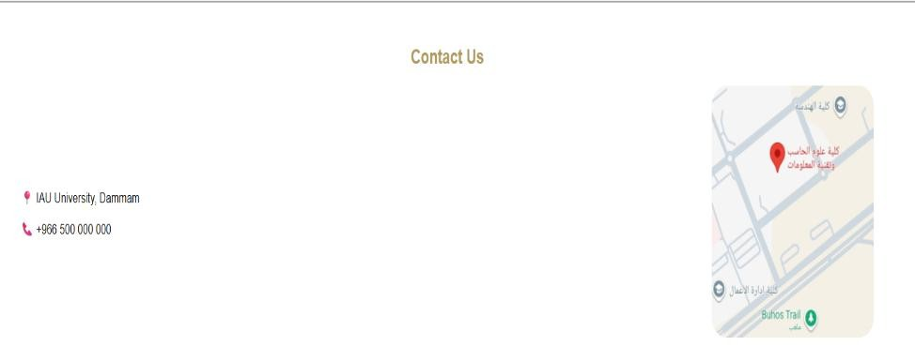

Admin Features

Product Management
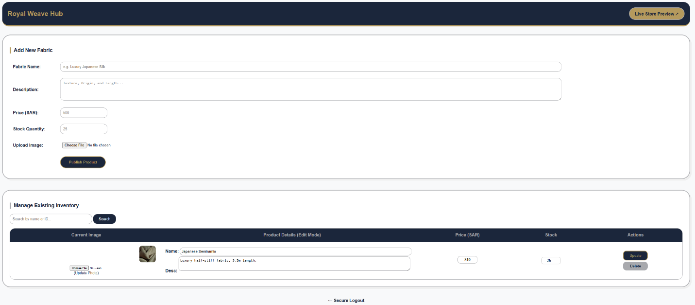
Admin control panel has full control over product management. An Admin can add new products, add their details and upload the images needed. Also, modifying existing products that includes updating their images and deleting unneeded products.

Search Functionality
Admin control panel includes a special search feature that allows an admin to quickly locate specific products. Improving efficiency when managing large numbers of products.

Admin Navigation Flow
The admin navigation flow begins with accessing the admin control panel, then logging in using the admin credentials. From there, the admin can perform actions such as adding, modifying or deleting products.
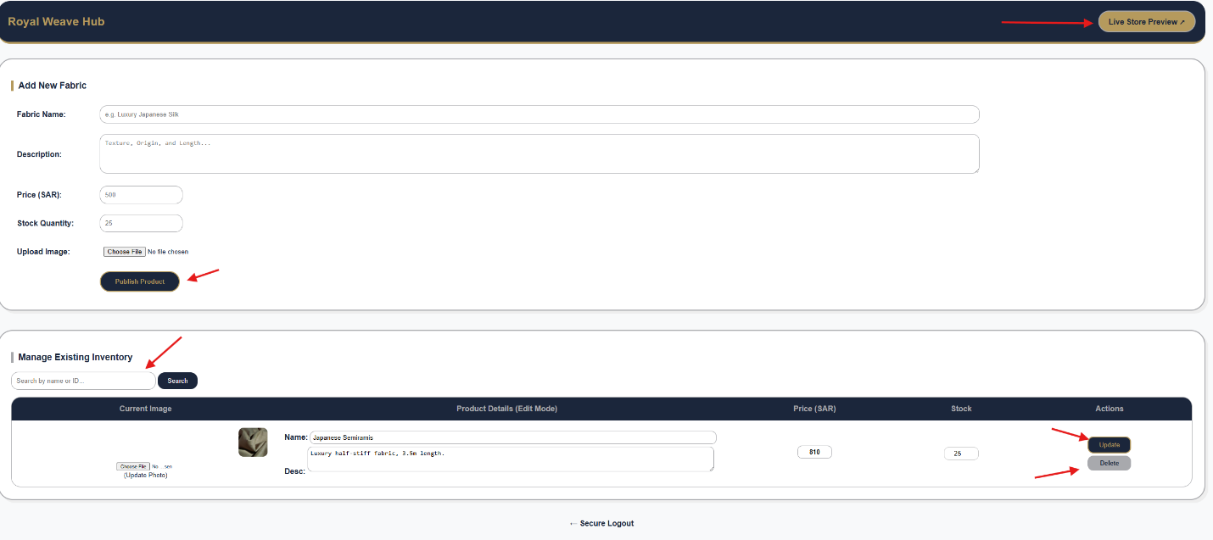

Admin Logout
After completing the necessary tasks, the admin can securely log out of the system. Maintaining security and preventing unauthorized access.

Teamwork and Contribution
We as group 7 worked together in a structured yet flexible manner, ensuring all parts of the project were well executed and integrated. Turki and Abdulmohsen focused primarily on
developing the HTML structure, with Turki contributing to the report writing. Ziyad and Tamim were responsible for designing the database. Mohammed handled the CSS styling, creating a
consisted and user-friendly interface. Despite these primary roles, we as a team maintained a strong collaboration on the project, with all members contributing and reviewing each other’s work.

Conclusion
Royal Weave demonstrates the core features of a shopping web-based system in a front-end environment. Providing essential features such as product browsing, detailed viewing, cart management and admin control.

